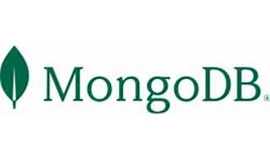



Explore

[Certainly**MongoDB** is an open-source, **document-oriented NoSQL database** that stores data in flexible, JSON-like documents and is designed for scalability and handling large amounts of unstructured data1](https://www.geeksforgeeks.org/what-is-mongodb-working-and-features/)[2](https://www.mongodb.com/what-is-mongodb)[3](https://www.ibm.com/topics/mongodb)[4](https://www.guru99.com/what-is-mongodb.html). Here’s a concise definition:

[**MongoDB** is a NoSQL database that uses **JavaScript-like documents** with optional schemas, allowing users to access data from various programming languages and data tools1](https://www.geeksforgeeks.org/what-is-mongodb-working-and-features/).

For free learning resources, here are **five reference links** where you can explore MongoDB:

1. [**MongoDB Official Documentation**](https://www.mongodb.com/what-is-mongodb): The official documentation provides comprehensive information about MongoDB’s features, architecture, and usage.
2. [**GeeksforGeeks: MongoDB Working and Features**](https://www.geeksforgeeks.org/what-is-mongodb-working-and-features/): GeeksforGeeks offers tutorials and examples to help you understand MongoDB.
3. [**IBM: What is MongoDB?**](https://www.ibm.com/topics/mongodb): IBM’s overview explains MongoDB’s nonrelational approach and its use of flexible documents.
4. [**DigitalOcean: What Is MongoDB?**](https://www.digitalocean.com/community/tutorials/what-is-mongodb): DigitalOcean’s tutorial covers the basics of MongoDB and its classification as a NoSQL database.
5. [**Guru99: Introduction to MongoDB**](https://www.guru99.com/what-is-mongodb.html): Guru99 provides insights into MongoDB’s document-oriented structure and its use for high-volume data storage.

Feel free to explore these resources to enhance your understanding of MongoDB! 🚀📚